**IT2120 - Probability and Statistics**

**Lab Sheet 07**

**IT24104341**

**Haputhanthiri R.S**

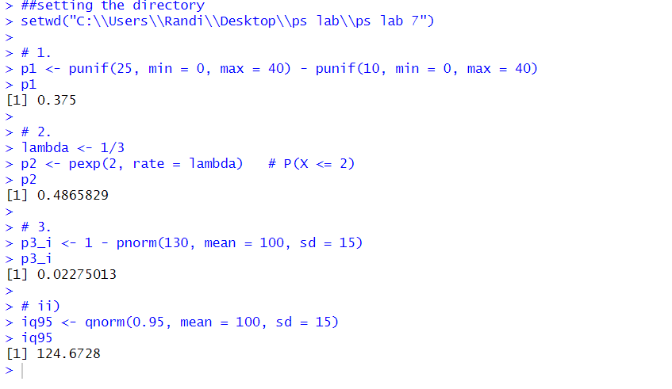

1. A train arrives at a station uniformly between 8:00 a.m. and 8:40 a.m. Let the random variable X represent the number of minutes the train arrives after 8:00 a.m. What is the probability that the train arrives between 8:10 a.m. and 8:25 a.m.?

Uniform(0,40): probability train arrives between 10 and 25 = (25−10)/40 = 15/40 = 0.375 (37.5%).

1. The time (in hours) to complete a software update is exponentially distributed with rate λ = 1 3 . Find the probability that an update will take at most 2 hours.

Exponential(rate = 1/3): P(T ≤ 2) = 1 − exp(−(1/3)*2) = 1 − e^(−2/3) ≈ 0.4865829 (≈48.66%).

1. Suppose IQ scores are normally distributed with a mean of 100 and a standard deviation of 15.
2. What is the probability that a randomly selected person has an IQ above 130?
3. What IQ score represents the 95th percentile?

Normal(μ=100, σ=15):

1. P(IQ > 130) = 1 − Φ((130−100)/15) = 1 − Φ(2) ≈ 0.02275 (≈2.275%).
2. 95th percentile = μ + z_{0.95}·σ = 100 + 1.6448536·15 ≈ 124.6728 (≈124.67 IQ).